**MARKETPLACE TECHNICAL FOUNDATION – COMFORTY**

**1. Technical Requirements:**

* ***Frontend Requirements***
* ***User-Friendly***: Easy navigation and intuitive product browsing.
* ***Responsive Design***: Mobile, tablet, and desktop support.
* ***Essential Pages***: Home, Product Listing, Product Details, Cart, Contact, About, FAQS, Checkout, Order Confirmation.
* ***Sanity CMS as Backend***
* ***Data Management****:* Manage products, customers, and orders.
* ***Schema Design****:* Create schemas for Products, Orders, and Customers.
* ***API Integration****:* Use Sanity APIs for frontend data fetching.
* ***Third-Party APIs***
* ***Shipment Tracking***: Fetch delivery updates (e.g. ShipEngine, More).
* ***Payment Gateway****:* Secure payments (e.g., Snipcart, more).
* ***Notifications****:* Send order confirmations via email or SMS.

**2. Design System Architecture:**

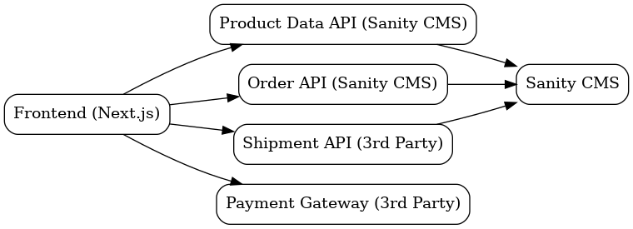

**3. Plan API Requirements:**

* **Product**
* **Endpoint Name**: /products
* **Method**: GET
* **Description**: Fetch all available products from Sanity.
* **Response**: Product details (ID, name, price, description, stock, image).
* **Order**
* **Endpoint Name**: /orders
* **Method**: POST
* **Description**: Create a new order in Sanity.
* **Payload**: Customer info, product details, payment status.
* **Customer**
* **Endpoint Name**: /customers
* **Method:** POST
* **Description:** Register a new customer in the system.
* **Payload:** Customer info (name, email, address).
* **Delivery Zone**
* **Endpoint Name:** /delivery-zones
* **Method:** GET (Third Party. e.g. ShipEngine, etc.)
* **Description:** Fetch available delivery zones.
* **Response:** Delivery zone details (ID, name, delivery cost).
* **Payment**
* **Endpoint Name:** /payment
* **Method:** POST (Third Party. e.g. Snipcart, etc.)
* **Description:** Process a payment for an order.
* **Payload:** Payment info (order ID, amount, payment method).
* **Response:** Payment status (successful or failed).

**4. Technical Documentation:**

* 1. **System Architecture Overview:**
  + ***Frontend (Next.js)***
* **Role:** Displays the user interface, handles interactions, and provides server-side rendering for fast load times and SEO.
* ***Backend (Sanity CMS)***
* **Role:** Manages and stores dynamic content (products, orders, customer, delivery zone, payment) and provides APIs for the frontend to fetch data.
* ***Third-Party APIs***
* **Role:** Integrates external services for payment processing (Snipcart, more), shipping (shipengine, etc.), and other functionalities.
* ***Database (Managed by Sanity)***
* **Role:** Stores structured data (products, users, orders) for easy access and management through Sanity’s APIs.
  1. **Key Workflows:**
  + **Add to Cart**
* User adds products to cart (frontend updates state).
  + **Checkout**
* User enters shipping info, and shipping rates are fetched via ShipEngine.
  + **Payment**
* User makes payment via Snipcart API.
  + **Order Confirmation & Delivery**
* Order is confirmed, and shipping label is created via ShipEngine; user gets tracking details.
  1. **Workflow Diagram:**

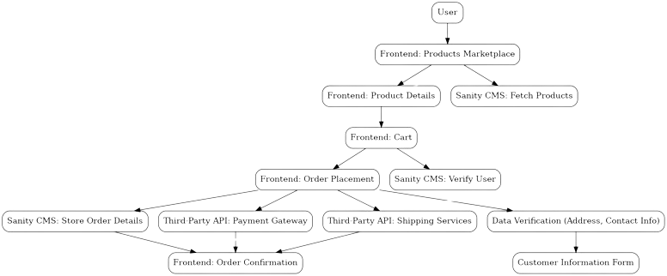

* 1. **Data Schema Design:**

**Entities and Relationships**

* **Product**
* **Fields:**
  + ID (number)
  + Name (string)
  + Price (number)
  + Description (text)
  + Image (image)
  + Stock (number)
* **Order**
* **Fields:**
  + ID
  + Customer ID
  + Quantity
  + Total
  + Order Status
* **Customer**
* **Fields:**
  + Customer ID
  + Name
  + Email
  + Phone
  + Shipping Address
* **Delivery Zone**
* **Fields:**
  + Zone ID
  + Region
  + Delivery Time, Charges
  + Available Options
* **Payment**
* **Fields:**
  + Payment ID
  + Order ID
  + Amount
  + Payment Method
  + Status
  1. **Technical Roadmap:**
* **Phase 1: Planning**
* Define scope, features, wireframes.
* Deliverables: Scope, UI mockups.
* **Phase 2: Frontend**
* Set up Next.js, cart, CMS integration.
* Deliverables: Product catalog, cart.
* **Phase 3: Backend**
* Set up Sanity CMS, API routes, third-party integrations.
* Deliverables: Backend, payment tracking.
* **Phase 4: Payment & Shipping**
* Integrate Snipcart, ShipEngine.
* Deliverables: Payment, shipping setup.
* **Phase 5: Testing**
* Test and optimize.
* Deliverables: Bug-free platform.
* **Phase 6: Deployment**
* Deploy site, set up monitoring.
* Deliverables: Live site.
* **Phase 7: Post-Launch**
* Monitor and update.
* Deliverables: Regular updates.

**Name : Tanzeel Sarwar**

**Roll Number : 00064068**

**Shift : Sunday 2 to 5 pm**